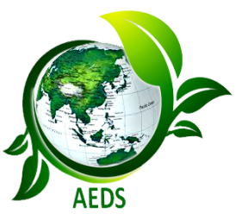

एग्रो एनवायर्नमेंटल डेवलपमेंट सोसाइटी (ए.इ.डी.स.)
मझरा घाट, रामपुर -245922, उत्तर प्रदेश, भारत
Agro Environmental Development Society (AEDS)
Majhra Ghat, Rampur-244922, Uttar Pradesh, India
(Registered Under the Society Registration Act XXI, 1860)
www.aedsi.org

Life Membership Form
Membership Fee Payment Details: Life Membership fees by Online/Mob.App/NEFT/Net-Banking transfer in favour of Pharma Medical Development Society A/C No: 38837079014, State Bank of India, Saifni Shahabad, Bilari Road, Saifni Rampur-244922. IFSC: SBIN0018205, MICR Code: 244002161. Transaction/Fund Transfer No………………...Payment Transfer Date…………………………………….

Name: Mr./Ms/Mrs/Dr./Prof (Block letters) |  |  |  |  |  | Photo
Designation & Specilization
Complete Instititional Address
Correspondance Add. with Pin Code
Date & Place of Birth

Nationality
Contact No.
Whatsapp No.
E-mail
Life Membership Fee |  |  | Indian/SAARC Countries Members:  5500 INR |  |  | Foreign Members: 500 USD
Academic Profile (Education Qualification) Graduation Onwards

Degree |  | College/University/Institute | Year of Passing | Subject |  |  | % /Division/ CGPA
Total Service Period

Name of Post |  |  | Year |  | Duration
a
b
c
d
Significant achievements/Academic contributions in the relevant area of Research/ Teaching/Extension/Coordination & Management in precise form.

I hereby declare that the information furnished above are true and correct to the best of my knowledge and belief. In case, any of the above information is found false or untrue or misleading. I will undertake to inform you of any changes therein, immediately.

Date: Signature of Applicant

